Analytical Problem Solving
Intelligent Path Planning for a Warehouse Delivery Robot
A. PEAS description
PEAS means Performance measure, Environment, Actuators, and Sensors. It is used to describe how an intelligent agent works.
Performance measure
The robot should:
- Deliver the package to cell (5,5).
- Start from cell (1,1).
- Avoid all blocked cells.
- Take the shortest possible route.
- Complete the delivery with minimum movement cost.
- Avoid collisions with shelves and other obstacles.
Environment
The environment is a warehouse represented by a 5 \times 5 grid.
- Starting cell: (1,1)
- Destination cell: (5,5)
- Blocked cells: (2,2), (2,3), (3,3), (4,2), and (4,4)
- The robot can move only horizontally or vertically.
- Diagonal movement is not allowed.
- Each movement has a cost of 1.
The warehouse is a known, static, discrete, and fully observable environment because the positions of the shelves and the destination are already given.
Actuators
The actuators are the parts that make the robot move. They include:
- Left motor
- Right motor
- Wheels
- Braking or stopping mechanism
Using these actuators, the robot can move Up, Down, Left, or Right.
Sensors
The robot may use the following sensors:
- Position sensor to know its current cell.
- Obstacle sensor to detect blocked cells.
- Camera or grid sensor to identify the path.
- Package sensor to confirm that the package is delivered.
Therefore, the robot uses its sensors to understand its position and the actuators to move towards the destination.

B. Type Of Agent
The most suitable agent for this problem is a goal-based agent.
The robot has a specific goal: it must reach cell (5,5) and deliver the package. To achieve this goal, it has to examine possible movements and select a safe path from (1,1) to (5,5).
A simple reflex agent is not the best choice because it only reacts to the current situation. For example, it may see an obstacle in front of it and move in another direction without remembering the complete route.
A model-based agent can remember the warehouse layout, but the main purpose of this problem is reaching a particular destination. A utility-based agent could consider additional factors such as battery level, time, and safety. However, these factors are not given in the question.
Hence, a goal-based agent is the best choice because it selects actions according to the final goal of delivering the package.

C. Search Problem Formulation
Initial state
The initial state is the starting position of the robot:
Initial\ State=(1,1)
Goal state
The goal state is the delivery position:
Goal\ State=(5,5)
The robot reaches the goal when it arrives at cell (5,5).
Actions
The robot can perform four actions:
Actions=\{Up, Down, Left, Right\}
An action is allowed only when the resulting cell is inside the grid and is not blocked.
For example, from (1,1):
- Right leads to (1,2).
- Down leads to (2,1).
- Up and Left are not possible because they go outside the grid.
Transition model
The transition model explains the result of each action.
For example:
Result((1,1),Right)=(1,2)
Result((1,1),Down)=(2,1)
If the robot tries to move into a blocked cell, the action is not allowed. For example:
Result((1,2),Down)=(2,2)
is not permitted because (2,2) is blocked.
Path cost
Every valid movement has a cost of 1.
Cost(\text{each movement})=1
Therefore:
Total\ path\ cost=\text{number of movements}
The best solution is the valid path with the lowest total cost.

D. Breadth-First Search
BFS explores the search space level by level. It uses a queue, which follows the first-in-first-out rule.
For this solution, the movement order is taken as:
Right,\ Down,\ Left,\ Up
Already visited cells are not added again to the queue.
BFS queue expansion
The front of the queue is shown on the left.
Step | Expanded cell | Queue after expansion
0 | — | (1,1)
1 | (1,1) | (1,2), (2,1)
2 | (1,2) | (2,1), (1,3)
3 | (2,1) | (1,3), (3,1)
4 | (1,3) | (3,1), (1,4)
5 | (3,1) | (1,4), (3,2), (4,1)
6 | (1,4) | (3,2), (4,1), (1,5), (2,4)
7 | (3,2) | (4,1), (1,5), (2,4)
8 | (4,1) | (1,5), (2,4), (5,1)
9 | (1,5) | (2,4), (5,1), (2,5)
10 | (2,4) | (5,1), (2,5), (3,4)
11 | (5,1) | (2,5), (3,4), (5,2)
12 | (2,5) | (3,4), (5,2), (3,5)
13 | (3,4) | (5,2), (3,5)
14 | (5,2) | (3,5), (5,3)
15 | (3,5) | (5,3), (4,5)
16 | (5,3) | (4,5)
17 | (4,5) | (5,5)
18 | (5,5) | Goal found
BFS final path
(1,1)\rightarrow(1,2)\rightarrow(1,3)\rightarrow(1,4)
\rightarrow(1,5)\rightarrow(2,5)\rightarrow(3,5)
\rightarrow(4,5)\rightarrow(5,5)
The movement sequence is:
Right,\ Right,\ Right,\ Right,\ Down,\ Down,\ Down,\ Down
Number of movements:
4+4=8
Therefore:
\boxed{\text{BFS path cost}=8}
BFS gives the shortest path because all movements have the same cost.
Input
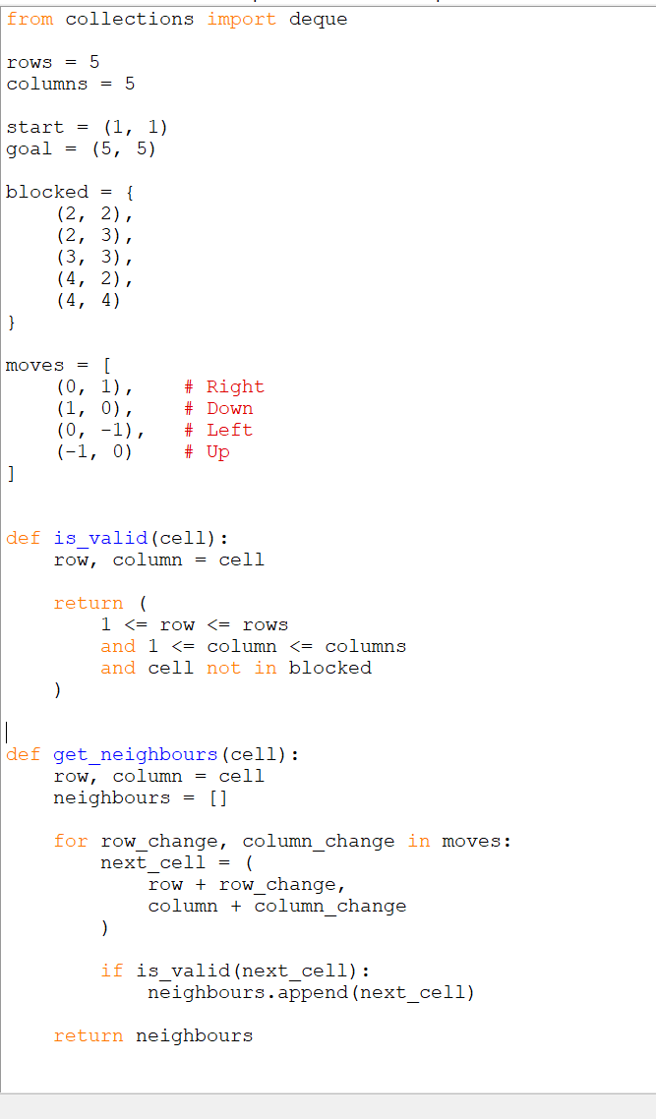
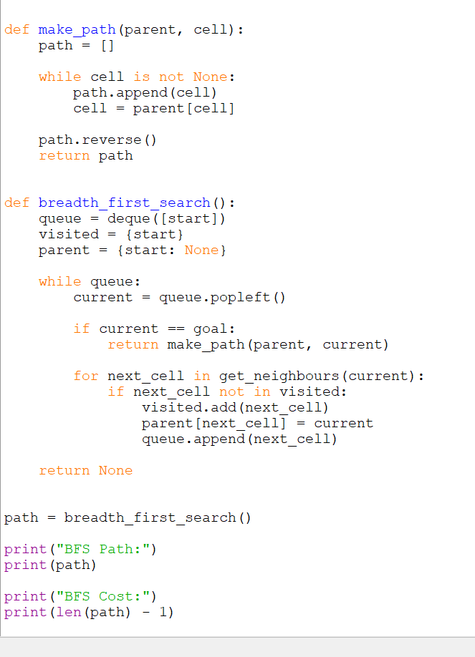
Output
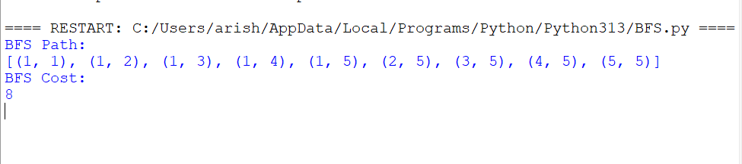

E. Depth-First Search
DFS explores one path as deeply as possible before coming back and trying another path. It uses a stack, which follows the last-in-first-out rule.
The same movement order is used:
Right,\ Down,\ Left,\ Up
The top of the stack is the rightmost cell in the table.
DFS stack expansion
Step | Expanded cell | Stack after expansion
0 | — | (1,1)
1 | (1,1) | (2,1), (1,2)
2 | (1,2) | (2,1), (1,3)
3 | (1,3) | (2,1), (1,4)
4 | (1,4) | (2,1), (1,5), (2,4)
5 | (2,4) | (2,1), (1,5), (3,4)
6 | (3,4) | (2,1), (1,5), (3,5)
7 | (3,5) | (2,1), (1,5), (4,5)
8 | (4,5) | (2,1), (1,5), (5,5)
9 | (5,5) | Goal found
DFS final path
(1,1)\rightarrow(1,2)\rightarrow(1,3)\rightarrow(1,4)
\rightarrow(2,4)\rightarrow(3,4)\rightarrow(3,5)
\rightarrow(4,5)\rightarrow(5,5)
The movement sequence is:
Right,\ Right,\ Right,\ Down,\ Down,\ Right,\ Down,\ Down
Number of movements:
8
Therefore:
\boxed{\text{DFS path cost}=8}
DFS finds an 8-movement path in this example. However, DFS does not always guarantee the shortest path. Its result depends on the order in which it explores the available movements.
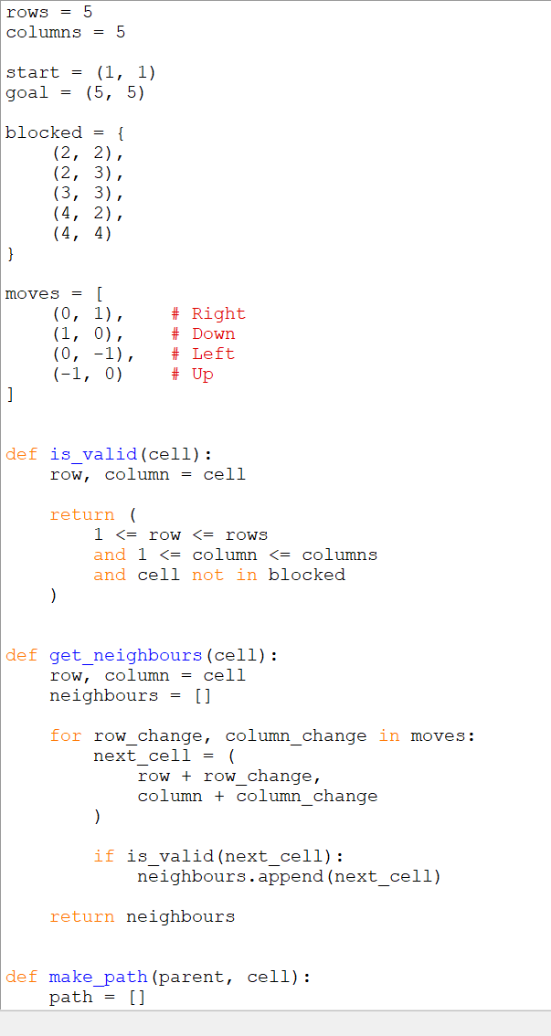

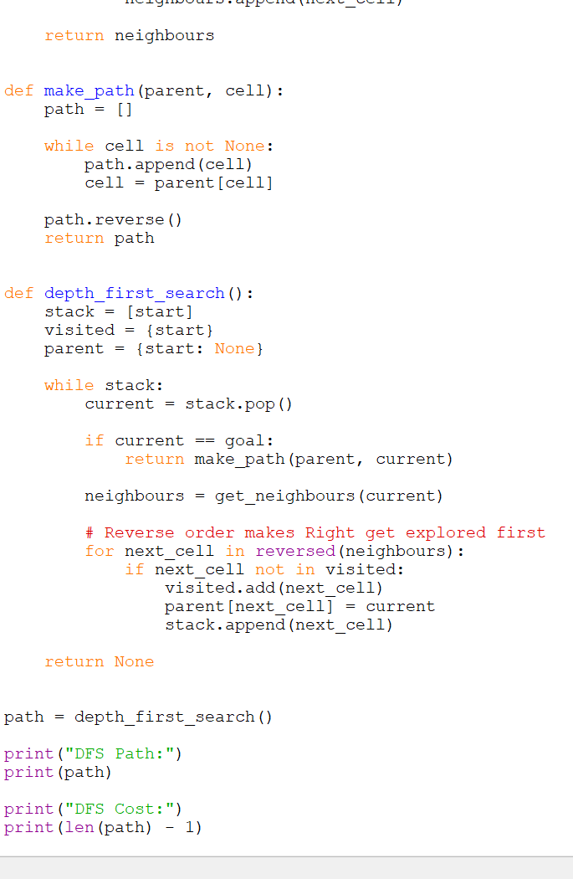
Output
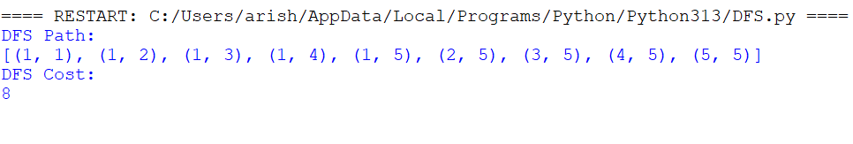

F. Comparison Of Bfs And Dfs
Point | BFS | DFS
Completeness | BFS will find a solution if one exists in this finite grid. | DFS can find a solution in this finite grid if visited cells are recorded.
Optimality | BFS is optimal because every movement has the same cost. | DFS is not guaranteed to find the shortest path.
Time complexity | O(b^d), where b is the branching factor and d is the depth of the shortest solution. | O(b^m), where m is the maximum depth of the search tree.
Space complexity | O(b^d). It may store many nodes in the queue. | O(bm). It generally stores fewer nodes.
Search method | Searches level by level. | Searches one branch deeply before backtracking.
Result in this problem | Finds an 8-movement shortest path. | Finds an 8-movement path for the selected movement order.
Main advantage | Guarantees the shortest route. | Uses less memory.
Main disadvantage | Requires more memory. | May return a longer route.
Suitable algorithm
BFS is more suitable for this warehouse robot.
The important requirement is to deliver the package using the shortest path. Since every movement costs 1, BFS checks paths in increasing order of length. Therefore, when BFS reaches (5,5), the path found has the minimum possible cost.
DFS may use less memory, but it can follow an unnecessary route before reaching the destination. This can increase the robot's travel distance, delivery time, and battery usage.
Therefore, the final choice is:
\boxed{\text{BFS is the better algorithm for this problem}}
This answer follows the assessment requirements by showing the problem interpretation, method selection, search steps, calculations, and practical meaning of the result.[1]

